You would have loops set up and things like that so that you can write just a small section of code, that maybe could insert 100 records. And to do that, we're going to reuse variables and structures in our program over and over again, so the clear statement, enables us to clear out a field, a variable or structure, so that we can reuse it and make sure that none of the data that currently exists in the structure.

Get supply to a new record. Now you will see the clear statement being used in awful lots of programs. Because every program that makes use of existing fields within that program, time and time again.

Once you finish working with a variable or structure. Use the clear statement and specify what you are going to clear out. You have a couple of options.

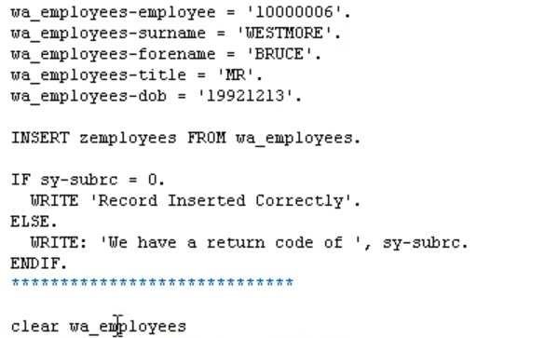

If we use clear WA employees, is going to clear the complete structure, so every field within the structure would be wiped clean.



Alternatively, you can specify individual fields.